Deschutes Rim Clinic Foundation – New Website!
By Sue Knapp, Board Member, White River Health District

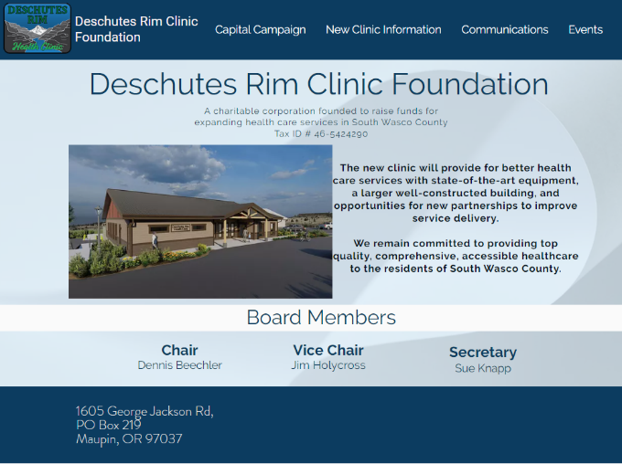
The Deschutes Rim Clinic Foundation has a new website! You can access it at www.deschutesrimclinicfoundation.org.
We greatly appreciate the assistance of the folks at Maupin Country Store and Hardware who were instrumental in getting this website completed and launched. We made the decision to separate out the Foundation from the Deschutes Rim Clinic’s website to improve access to foundation information. Check it out!
On the website, you can find Information on all aspects of the foundation, capital campaign and the new clinic. This includes level of funding received, our generous donors, granting foundations and entities, schematics and description of the new clinic, who is designing and building the clinic, and even how to donate.
Selection of ‘Donate’ in a drop down under ‘Capital Campaign’ takes you to a page with opportunities to use ‘GoFundMe’ and ‘Amazon Smile’. Ordering from Amazon via ‘Amazon Smile’ allows one to donate to the charity of their choice. The GoFundMe option uses PayPal or credit/debit card. If you are interested in writing as check, information is provided on that as well.
We are still awaiting approval of our USDA loan application. Some new requirements at the federal level required us to submit more information, delaying the process. We are starting to apply for more grants to add to those already received from Maybelle Clark Macdonald Fund, Randall Charitable Trust, and the Oregon Community Foundation. We greatly appreciate donations from the community that continue to come.
Construction drawings for the new clinic are near completion. Because we changed the building footprint and interior design to more appropriately match what we could afford and what the community needed, the permitting process will need to be redone. Once that is completed (and we receive approval on the loan), construction can start. Maybe in June? Fingers crossed.
Meanwhile the Deschutes Rim Health Clinic continues to pursue certification as a Rural Health Clinic. This has required the rewriting of policies and procedures, development of new ones, and overall reorganization and updating of medical inventory and electronic medical records. .
COVID vaccinations have ramped up as the clinic receives more doses of the Morderna vaccine. Call the clinic to get on the list. Back in February we assisted Oregon Health Authority with COVID testing in Maupin; seventeen individuals received a test. When visiting the clinic, be sure to thank staff for all their hard work.

